# University of the People.

**Evans M Kioko.**

**Bsc Computer Science.**

**Programming Assignment Unit 2.**

# Assignment instructions

In this unit, we explored the basic concepts of Python variables, operators, and expressions in Python and construct Python functions that take arguments.

Before completing this assignment, review the reading material below:  
[Think Python: How to think like a computer scientist](https://greenteapress.com/thinkpython2/thinkpython2.pdf) Chapters 2 and 3

Ensure that you go through all the topics in chapters 2 and 3, including the examples and solving the questions in the exercises.

There are two parts to this assignment.

**Part 1**

The circumference of a circle is calculated by 2πr, where π = 3.14159 (rounded to five decimal places). Write a function called print_circum that takes an argument for the circle’s radius and prints the circle's circumference.

Call your print_circum function three times with different values for radius.

Include the following in your part 1 submission:

* The code for your print_circum function: 🡺

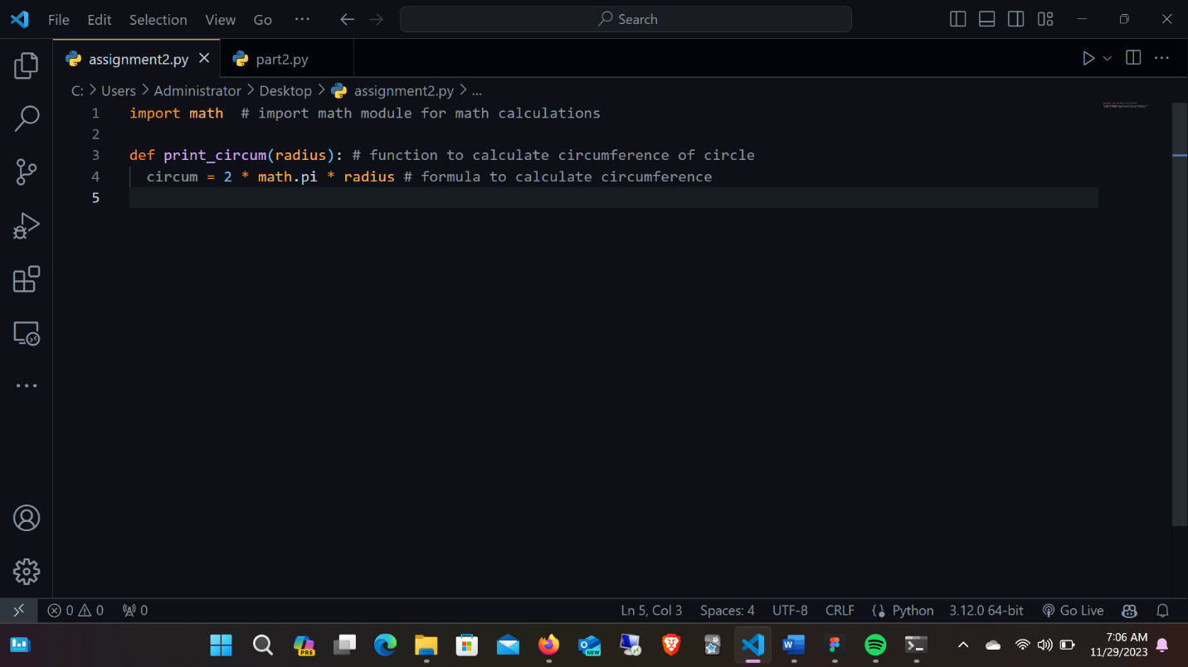

* The inputs and outputs to three calls of your print_circum.

Below is my work for the first part of this assignment 🡺

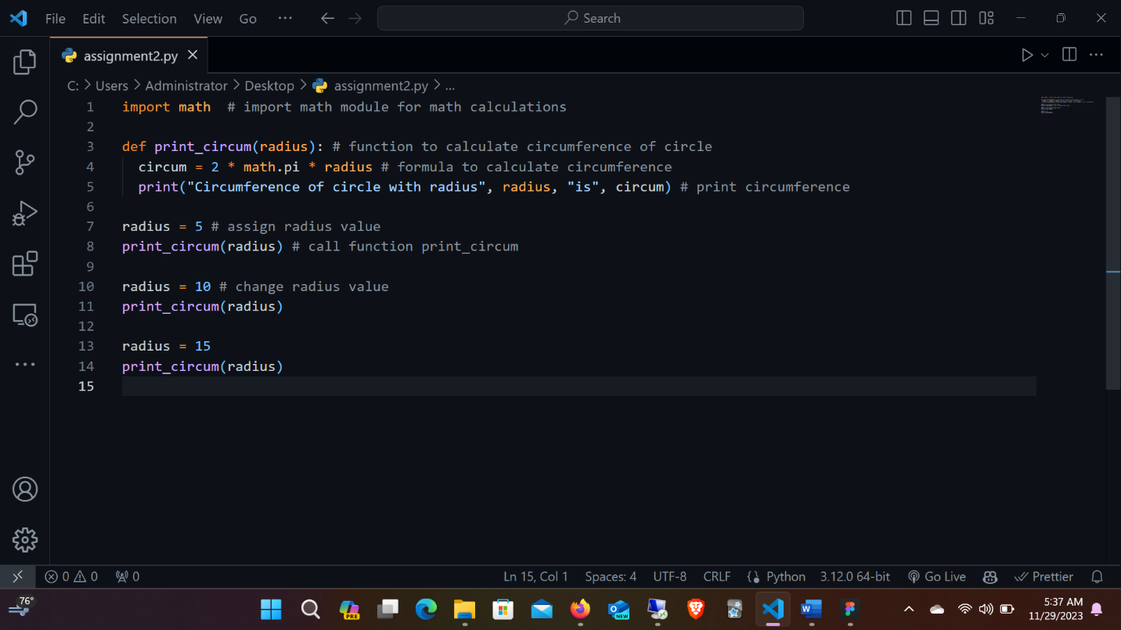

**Part 2**

Welcome to your first project.  Develop a catalog for a company. Assume that this company sells three different Items. The seller can sell individual items or a combination of any two items. A gift pack is a special combination that contains all three items. Here are some special considerations:

A. If a customer purchases individual items, he does not receive any discount.    
B. If a customer purchases a combo pack with two unique items, he gets a 10% discount.    
C. If the customer purchases a gift pack, he gets a 25% discount.

Write a function for the above scenario. Perform the calculations in code wherever applicable.  The function should be your own creation, not copied from any other source.  The final output should look like:

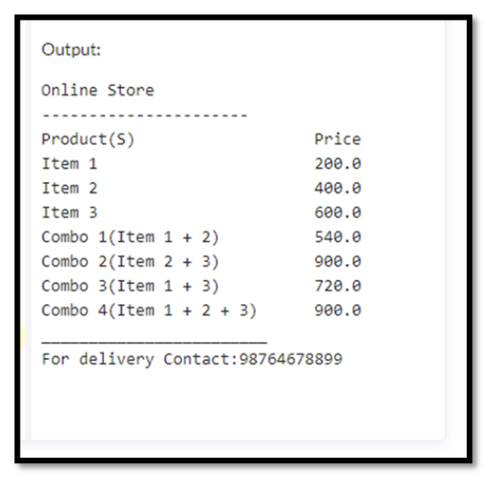🡺

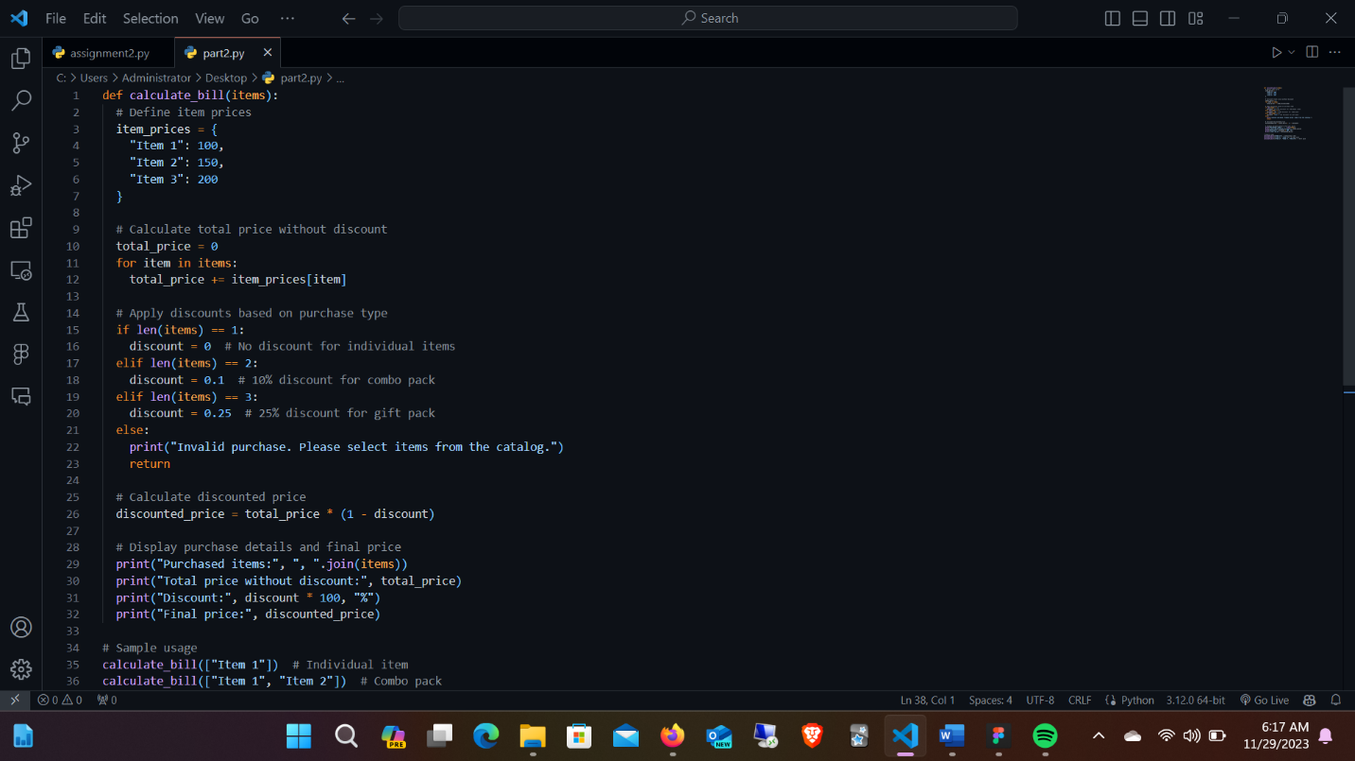

**OUTPUT 🡺**

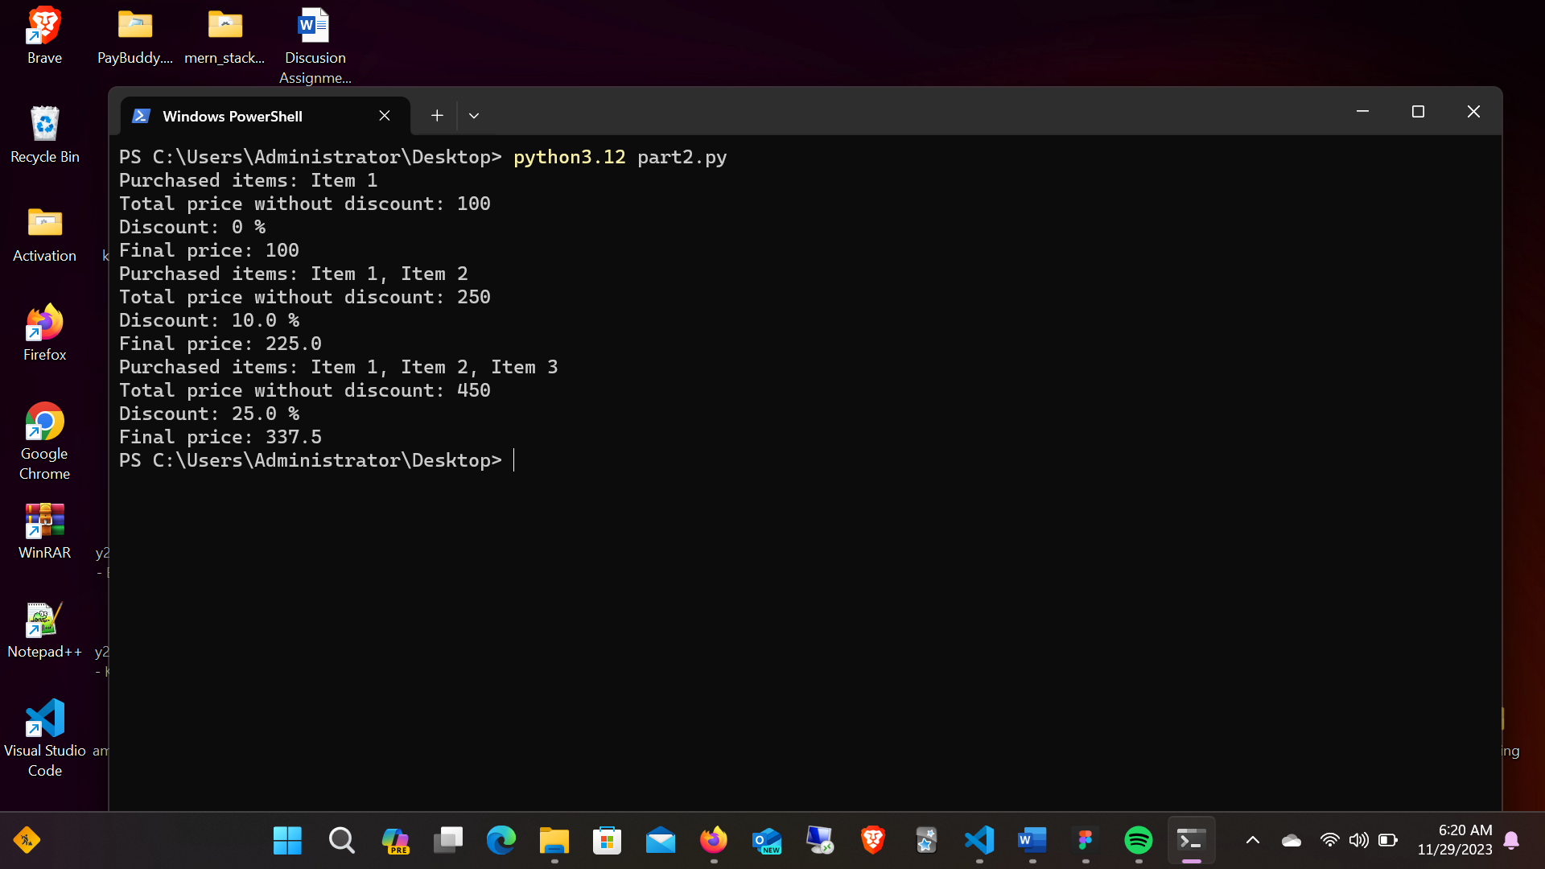

Include the following in your part 2 submission:

* The code for the function that you created.
* The Output of the code.
* A description of what feature(s) your function illustrates.
* The code and its output must be explained technically. The explanation can be provided before or after the code, or in the form of comments within the code.

If you use an informational source, be sure to identify the source and share the link to the source you used.